**DAA ASSIGNMENT – 6**

**Shashank K**

**SE21UCSE198**

**CSE 3**

**Implementation**

The constraints given to us are number of police officers and steps ‘K’. To maximize the number of thieves caught we can use Manhattan distance to calculate number of steps required to reach the closest thief.

If the Manhattan distance is less than or equal to the steps constraint we mark that respective thief as ‘caught’ and is added to a set.

As one policeman can only capture one thief, we must constantly check if a specific thief is present in the set or not.

Max number of thieves given thieves > policemen is equal to number of policemen.

**Inputs and outputs**

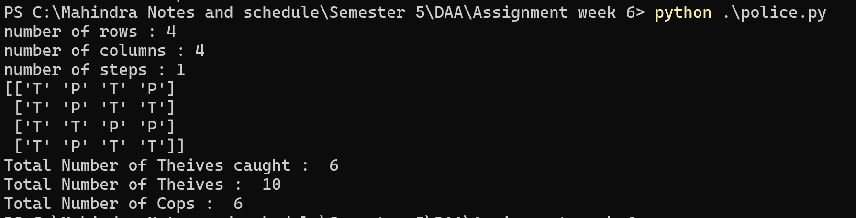

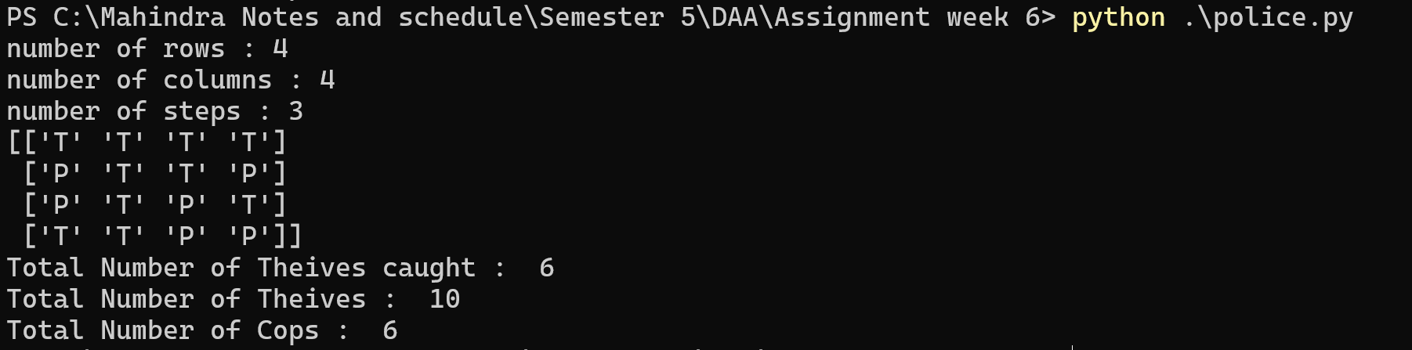

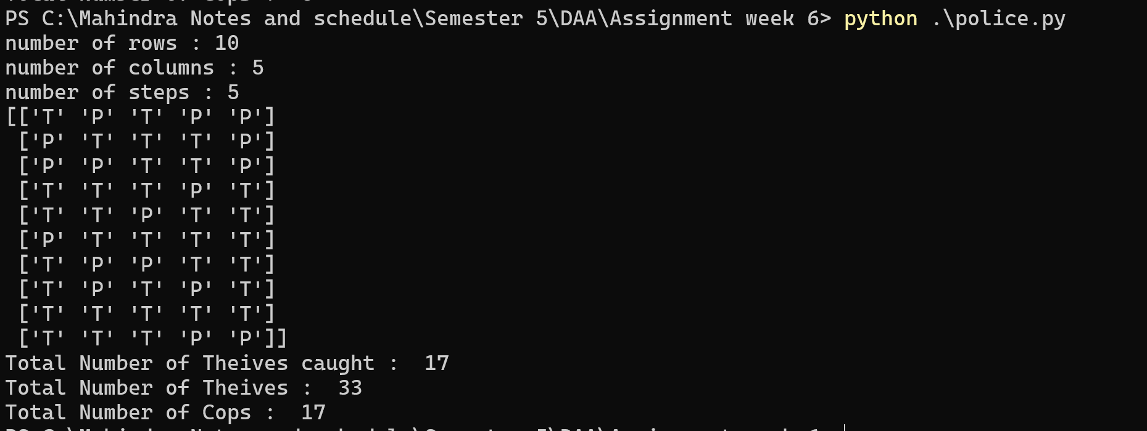

**4**

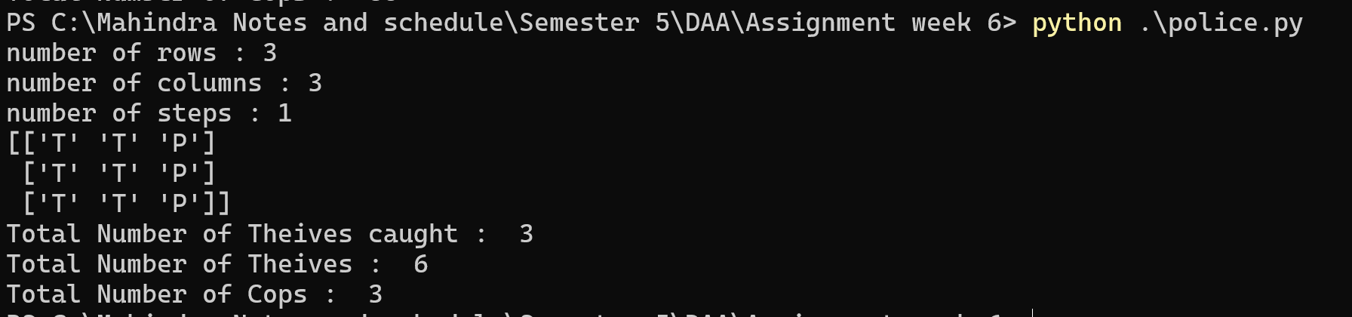

**Complexity :** Time = O(n^2) , space = O(n)